

Target: \_\_\_/34 or \_\_\_\_ % 👍 👎

34

**Year 7 HASS- Geography**

***Task 3: In Class Assessment (2.5% weighting)***

***(Livability skills test)***

Name:\_\_\_\_\_\_\_\_\_\_\_\_\_\_\_\_\_\_\_\_\_\_\_\_ Teacher: \_\_\_\_\_\_\_\_\_\_\_\_\_\_\_\_\_\_\_

**Time: 5 minutes reading time and 40 minutes working time.**

**Section 1: Liveability**

1. Define the term ‘liveability’. Provide examples to support your definition.

(2 marks)

**-The qualities of a place that contribute to the quality of life of those who live or visit there. (1 mark)**

**-Any suitable examples (1 mark)**

1. Look at the two photographs of the same laneway in Melbourne in 1994 and 2004. The laneway is in a central location in the central business district, close to one of the major railway stations.

|  |  |
| --- | --- |
| Macintosh HD:Users:sofijastefanovic:Desktop:PGEO_PR7_Ts8_02.jpg |  |
| **Source 1:**  *Melbourne Laneway 1994* | **Source 2:**  *Melbourne Laneway 2004* |

1. Look carefully at Source 1, the Melbourne laneway in **2004**.
2. Describe **two** positive aspects of living in this place. (2 marks)

**1 mark for any of the following;**

-Pedestrian friendly

-A wide variety of choice (Many shops to choose from)

-Appears to be a lot of social interaction

-Close to public transport

-Cafes are popular (people queuing up), usually a good sign that they are of a high standard.

Please note as there was a mistake and the 2004 Melbourne laneway was labelled Source 1, please accept any reasonable answer if the student is referring to source 1. Students may mention lack of crowds.

1. Describe **two** negative aspects of living in this place. (2 marks)

**1 mark for any of the following;**

-Lack of open spaces

-Crowded

-Cleanliness

-Noise may be an issue due to the crowding

1. Compare Source 1 the Melbourne laneway in **1994** to Source 2 the laneway in **2004**. Which would be the more liveable of the two? Explain why. (3 marks)

(**Hint:** A good answer will include words such as **whereas** and **however**)

**-In Source 2 more social interaction appears to be happening. (1 mark)**

**-Businesses/cafes appear to be less appealing in Source 1 (1 mark)**

**-Uses words such as however, whereas (1 mark)**

**-Source 2 could be considered more liveable (1 mark)**

1. The table below shows the ranking results of Mercer’s Quality of Living Survey for 2018 for the top 20 cities. Refer to the list and answer the questions that follow.

|  |  |  |
| --- | --- | --- |
| **Rank** | **City** | **Country** |
| 1 | Vienna | Austria |
| 2 | Zurich | Switzerland |
| 3 | Auckland | New Zealand |
| 4 | Munich | Germany |
| 5 | Vancouver | Canada |
| 6 | Dusseldorf | Germany |
| 7 | Frankfurt | Germany |
| 8 | Geneva | Switzerland |
| 9 | Copenhagen | Denmark |
| 10 | Basel | Switzerland |
| 10 | Sydney | Australia |
| 12 | Amsterdam | Netherlands |
| 13 | Berlin | Germany |
| 14 | Bern | Switzerland |
| 15 | Wellington | New Zealand |
| 16 | Melbourne | Australia |
| 16 | Toronto | Canada |
| 18 | Luxembourg | Luxembourg |
| 19 | Ottawa | Canada |
| 19 | Hamburg | Germany |

*Source:* [*www.imercer.com*](http://www.imercer.com)

1. How many Australian cities are ranked in the top 20? Name them. (2 marks)

**There are two; Melbourne (1 mark) and Sydney (1 mark)**

1. What was the world’s most liveable city in 2018? (1 mark)

**Vienna (1 mark)**

1. What was Canada’s most liveable city? (1 mark)

**Vancouver (1 mark)**

1. What country has the same amount of liveable cities as Australia in the top 20? Name both of the cities from this country that feature in the top 20. (3 marks)

Country: **New Zealand (1 mark)**

City 1: **Auckland (1 mark)**

City 2: **Wellington (1 mark)**

**Section 2: Where Australians live**

Look at Source 3, the population density map for Australia below and then answer the questions below;

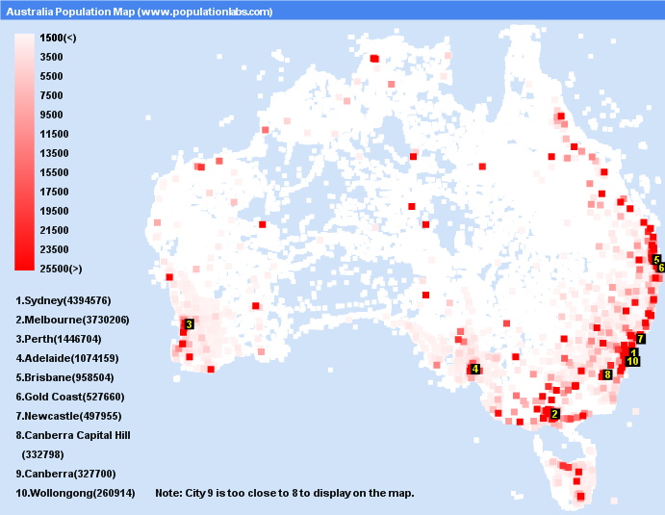

**Source 3:**

1. Using Source 3 above, what are **two** patterns that you notice about where most Australians live. (2 marks)

* **Most Australians live along the coast (1 mark)**
* **Mention of the east coast (1 mark)**

1. Outline some reasons why people choose to live in these particular areas.

*(****Hint****: A good response will refer to social, infrastructure, cultural, environmental and economic forces that influence liveability)* (4 marks)

* **1 mark for full sentence answers.**
* **Warmer climate (1 mark)**
* **Greater choice of recreational activities (1 mark)**
* **Aesthetics (1 mark)**
* **Greater employment opportunities as many of the locations are urban areas (1 mark)**
* **The infrastructure is well developed in many of these areas e.g public transport, shopping centres, services and healthcare (1 mark)**

**Section 3: Sketch Map**

Using Source 4, the map provided to you draw a sketch map of Narrogin.

You must include BOLTSS. The border has been drawn for you.

* You must **neatly** include, (using suitable colours):
* Narrogin Senior High School
* Narrogin Primary School
* Coles

(12 marks)

* Great Southern Highway
* Narrogin Railway
* Narrogin Speedway

LEGEND

* **A north symbol pointing to the top of the page. (1 mark)**
* **Four or more symbols are created for the legend (2 marks) OR… Two symbols have been created for the legend (1 mark)**
* **An appropriate title e.g Map of Narrogin has been placed in the box provided (1 mark)**
* **Student has used the same scale from the map [2cm=2km] (1 mark)**
* **Has included the source** *Map data © Google Australia* **(1 mark)**
* **1 mark for each one of the features of the map being showed in the correct place.**